Prepare your answers in a Microsoft Word doc file named **snifflab.doc**. In it, give numbered answers to these questions:

1. The number of bytes in the echo protocol exchange in section 4 above, according to the "Follow TCP Stream" window, is ________

2. The number of bytes in the echo protocol exchange in section 4 above, according to the Statistics/Conversation List/TCP window, is ________

3. The iptables command syntax to create a firewall rule prohibiting use of the standard echo protocol (Section 6 above) is:

   ________________________________________________________________________________________________________

4. J. Postel is:

   ________________________________________________________________________________________________________

5. The number of frames in section 9's datastream was ____________________

6. The average length/size (in bytes) of the frames in section 9's datastream was  ____________________

7. The most common frame size among the frames in section 9's datastream was ____________________

8. The maximum frame size among the frames in section 9's datastream was ____________________

9. For any of those max-sized frames, the size of  its ethernet payload portion was ____________________

10. For that frame, the size of the remainder of the packet (ie, its header) was ____________________

11. For that frame (and all the others like it) Wireshark names its highest-level payload (see the packet details pane). It's ____________________

12. The oberved value of the maximum frame size is interesting. It could not be any larger because (consider the reference graphic that follows):

   ________________________________________________________________________________________________________

For reference, question 12:

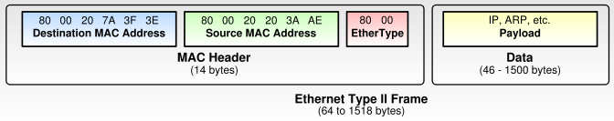

13. At the bottom of your file, insert the screen capture you generated in section 7 above.